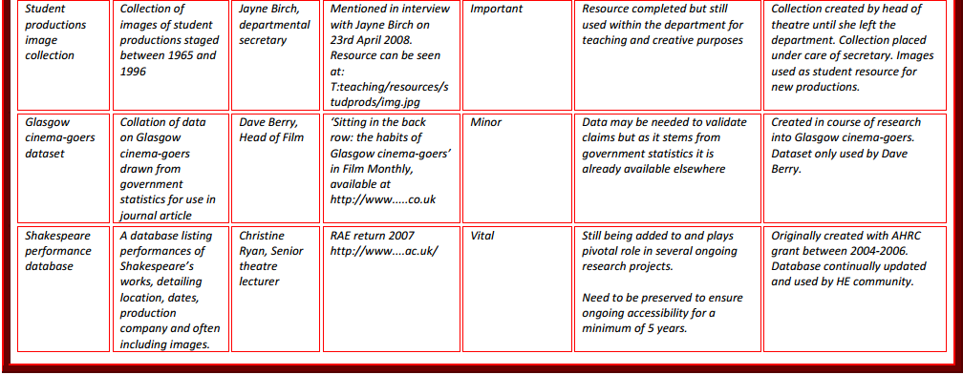

Data Asset Framework - http://www.data-audit.eu/
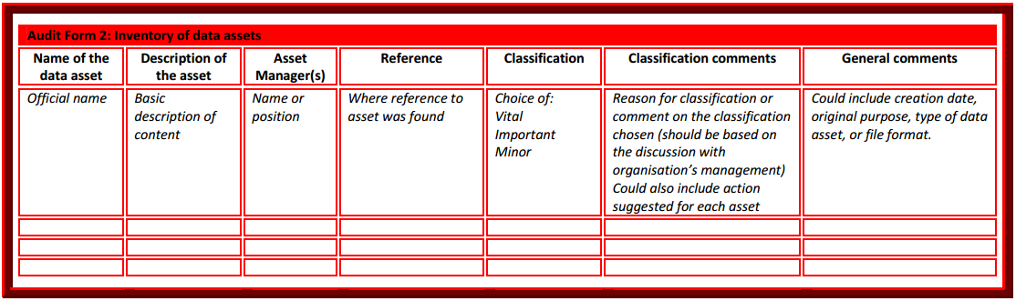
The National Archives Information Asset Register - http://www.nationalarchives.gov.uk/information-management/manage-information/policy-process/digital-continuity/step-by-step-guidance/step-2/

