Digital POWRR How-to Tech Tutorial
FITS- Activity for Mac

This is a demonstration of how to run the File Information Toolset (FITS) in a Mac. It is a command-line based tool. It is a tool that is available from Harvard: https://projects.iq.harvard.edu/fits.

What is FITS?
From the Harvard website:
https://projects.iq.harvard.edu/fits/fitsfaq
“FITS is a free and open source tool for identifying and validating file formats, extracting metadata embedded within files, and outputting the metadata in various formats. It was created to do some of the file processing tasks needed to support digital preservation repositories and applications.”

Where to download FITS?
https://projects.iq.harvard.edu/fits/downloads
Choose the latest version, usually found near the top of the page. As of the writing of this guide, the current release version is “fits-1.2.0.zip” released on August 15, 2017 at 128.9MB.

For the POWRR Institutes, we have completed the process of copying some test files to be used as inputs in the FITS program later and created a folder that can be used to store the output files from FITS. Now we proceed to installing Java, which is required by the FITS program.

Pre-requisite: Enable Terminal Access from Specific Folders
To work with FITS, you need to know folder paths. In the Mac OS, there are several ways of obtaining this information. One simple way is enabling a keyboard shortcut.

Open your System Preferences pane and then click on “Keyboards.” Click “Shortcuts,” and scroll down to “Files and Folders.” Click the checkbox by “New Terminal at Folder.”

Close the System Preferences tab.
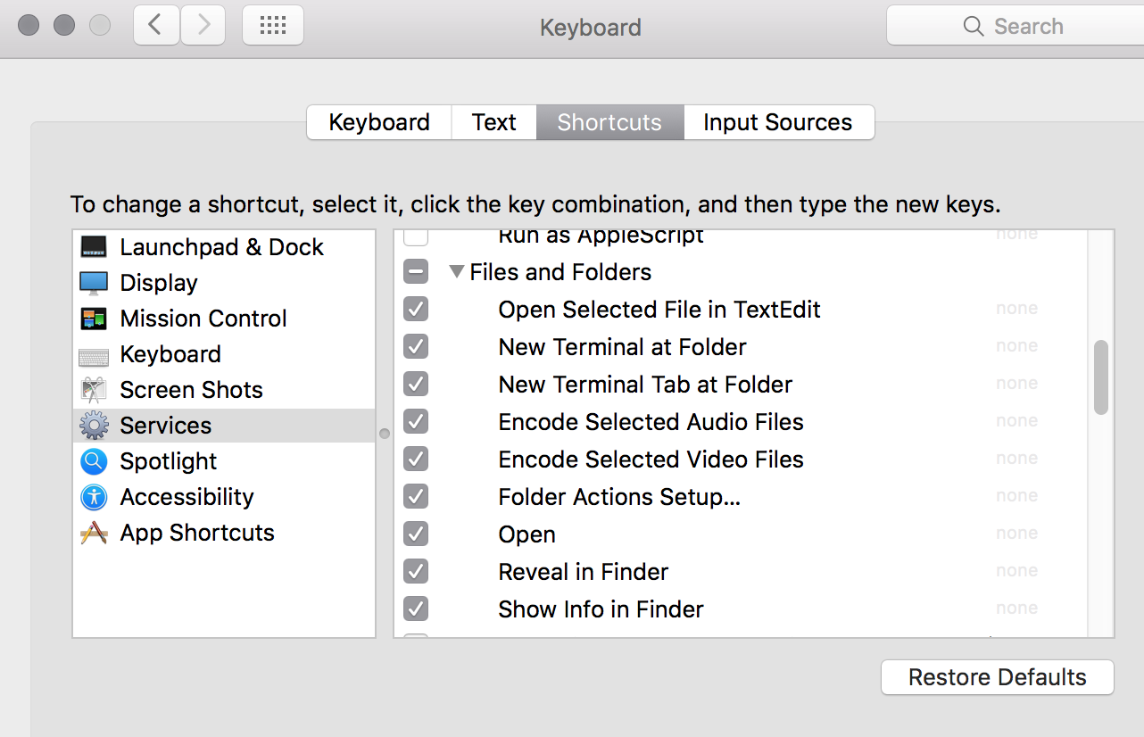
Now, when you right-click on a folder, you will have an option for a sub-menu called Services.

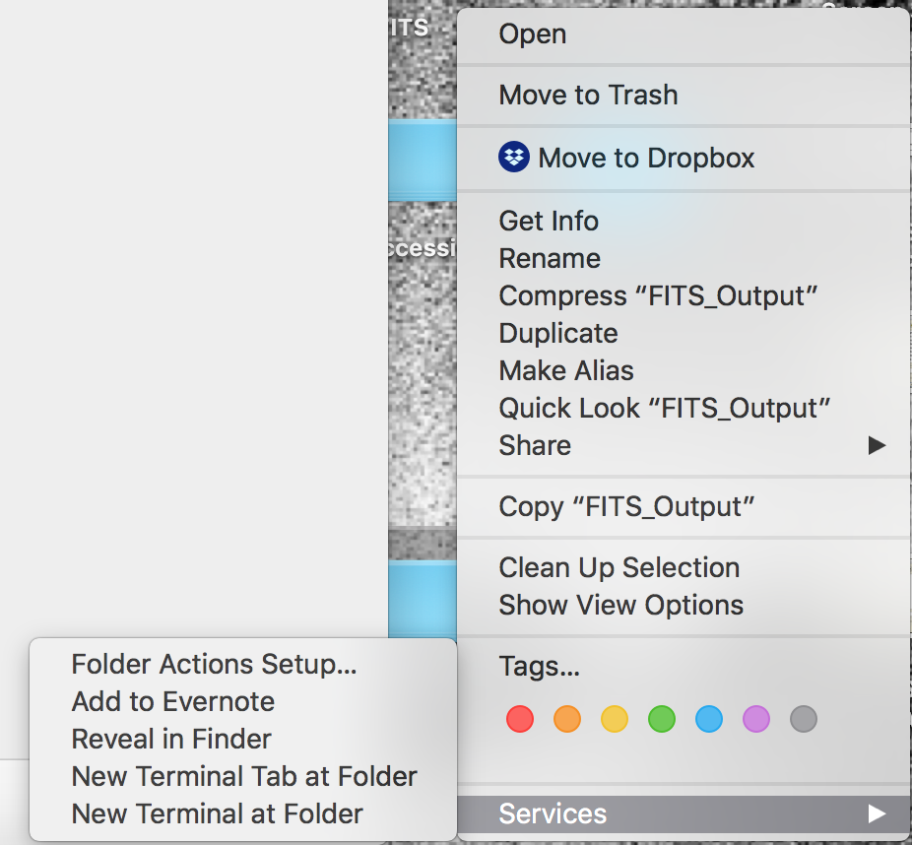
If you select “New Terminal at Folder,” Mac’s Terminal window will open, and your path will be automatically mapped to this location. (This means less typing and trying to figure out path variables!!)
If you give it a try, type pwd (for “print working directory”) and Terminal will display your current path.

DEMONSTRATION BEGINS HERE

Running FITS:
The FITS program was previously installed on your desktop. Double click on the folder, then click on fits-1.2.0. Right click on the second fits-1.2.0 folder, scroll down to “Services” and pick “New Terminal at Folder.” Terminal will launch.

Type ls –l to see what is inside of the fits-1.2.0 folder, and what permissions the files have. This should be the folder that contains the fits.sh file that is needed to start FITS in Mac. The first four characters of the file permissions tell you whether you can read, write, or execute the file as the owner of the file. The dash indicates that this is a file and not a directory. The r represents that the owner of the file (you) can read it; the w indicates that the owner of the file (you) can write to the file; the x indicates that the owner of the file (you) can ‘execute’ the file or run it. If the “x” is not present (you only see –rw-), then you will need to run the following command to give the fits.sh file the ‘execute’ permission, otherwise, FITS will not run.
    - Chmod +x fits.sh

- Then type: ls –l
Use this command to review the change made to execute permission on the fits.sh file. Make sure that the permissions now show as –rwx for that file.
- ./fits.sh
Use this command to start the FITS program. The information returned will explain briefly how to run the program. Below should be what you see.
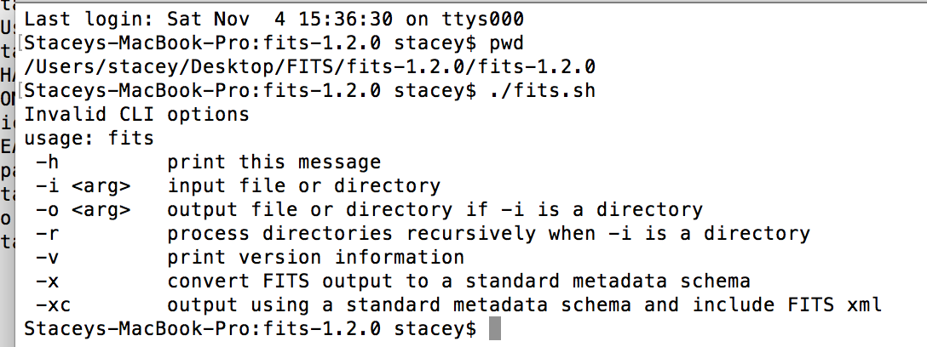

Based on the above information returned from the program, to run FITS, you will need to provide the program with the following:

- An input file or directory (that is the -i argument) that we wish to process through FITS. The input directory was created earlier for you; it is on the desktop and is called: Files.

- An output file or directory (that is the –o argument) that we wish to process through FITS. The output directory was created for you earlier; it is called Fits_Output.

- Optionally, the -r argument is included if a directory is given to the program so that directories are processed recursively.

For example, if our input directory of files to be processed are located in /Users/stacey/Desktop/Files, then the following command will run FITS on those files and place the output files in /Users/stacey/Desktop/Fits_Output:

./fits.sh -i /Users/stacey/Desktop/Files -o /Users/stacey/Desktop/Fits_Output

Your paths should be similar, but could be slightly different. To check, you can right click on “Files” and “FITS_Output” and select “Get Info.” Then simply highlight the entire path to the right of “Where.”
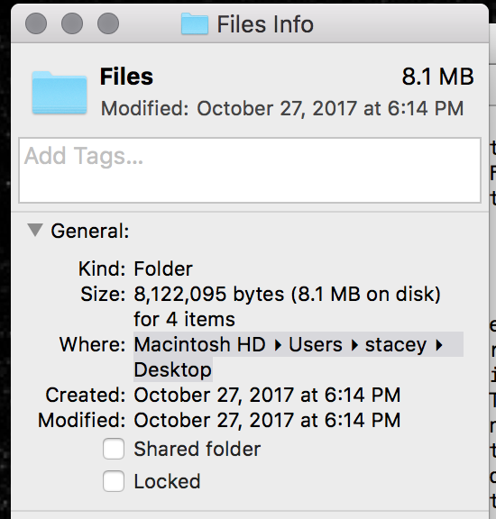
You can then paste that into the Terminal window directly, one at a time.

When you have the full path, hit return and FITS will run.

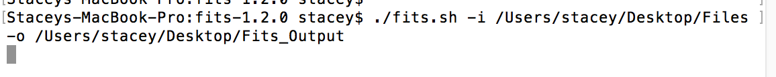
As you can see from this screenshot above, the program is now running.

When the program completes, the command prompt will return to the cursor as you see above

Navigate to your desktop and open the FITS_Output folder. You should see some xml files - one for each file you passed through FITS.
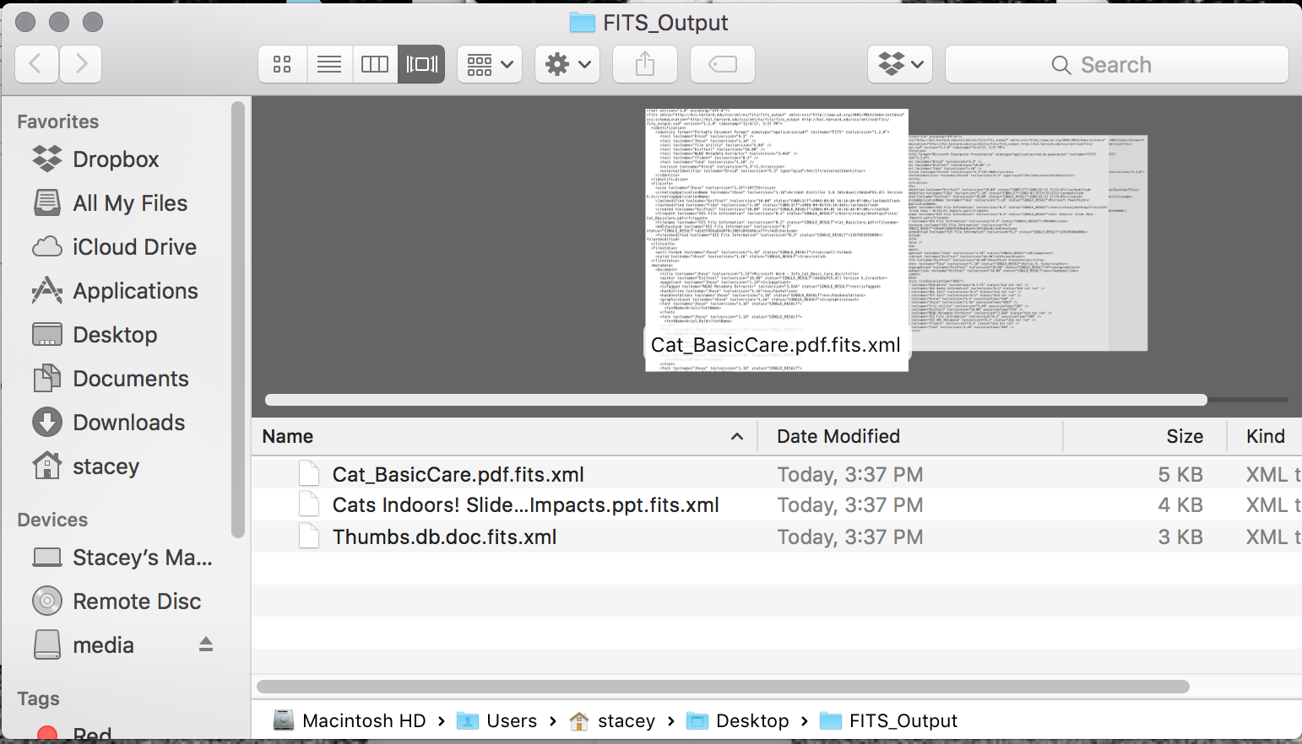

You have now successfully installed and run FITS in Mac via the command line!

