Why Should Digital Preservation Matter to You?
Intended for: Information Management(Librarian)
Everyone has a role to play in safeguarding our university’s digital assets.

The intellectual property of our institution is at risk. We must have an active digital preservation program in place to be a leading institution. Without such a program all the content we create is at risk of being lost.

Current estimates are that without digital preservation electronic records could become inaccessible within a few years, a decade at most. To ensure long-term viability and relevance of our work we need to begin a digital preservation program now as a core component of campus activities.

Facts about Digital Preservation
- As members of the institution realize the importance of digital preservation, the job of organizing and managing information changes. The formats have changed but the role of the information management professional is the same.

- You are in a trusted position and can help move digital preservation forward through collaboration and communication.

- Faculty and others might not understand the difference among backup, storage and preservation or how the idea of an Institutional Repository differs from digital preservation.

- We know our institution is at risk without a digital preservation program. We need our colleagues to understand the issues and the role they can play in managing and purging files to keep only what’s important.

- The library has a crucial role to play in managing the files under your purview. Be clear about your role and the role of others in the university. Point to specific examples where content is at risk. What if there was a web site or server failure and the content on the site or server was lost?

How Can You Help?
Everyone has a role to play in establishing a digital preservation program. Digital preservation activities are part of our core mission; they secure the intellectual capital represented in our teaching and research products. This is necessary to remain viable and attract and retain faculty, students and staff. We need to get the dialogue started and the funding identified to move this critical program forward.

What is Digital Preservation?
Digital preservation combines policies, strategies and actions to ensure long-term access to content that is born digital or converted to digital form regardless of the challenges of file corruption, media failure and technological change.

Digital preservation is an ongoing process, not a one-time activity, and needs to be addressed programmatically. Digital Preservation is more than a back-up.

Why do we need it?
Digital files become inaccessible over time unless they are managed and migrated to new technology as needed. Even content that resides on a web site or social media site is at risk.

For more information,
please contact:
<<Your Name Here>>
<<Your Contact Info. Here>>

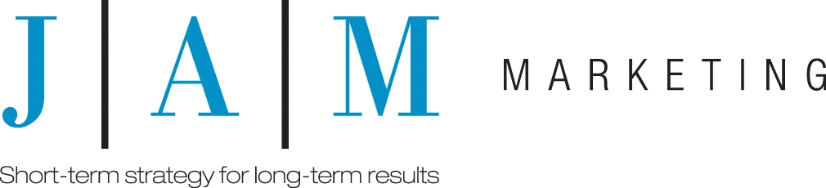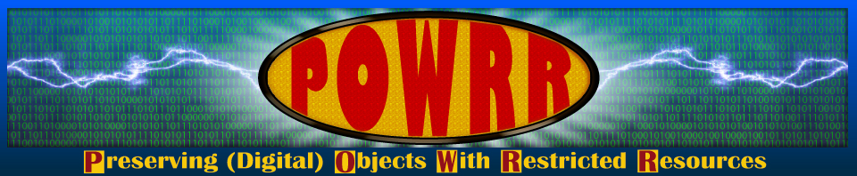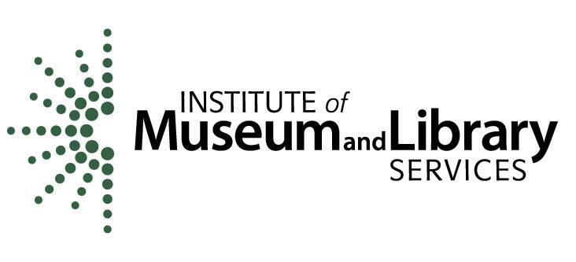
This information is provided as part of the Preserving (Digital) Objects with Restricted Resources (POWRR) project, made possible by a grant funded by the Institute of Museum and Library Services (IMLS). The project is the work of the Northern Illinois University Libraries in conjunction with a board of advisors and partner libraries at Chicago State University, Illinois State University, Illinois Wesleyan University, and Western Illinois University.

