Updated: 4 February 2015

In the three months following the workshop, did you initiate any digital preservation activities at your institution?

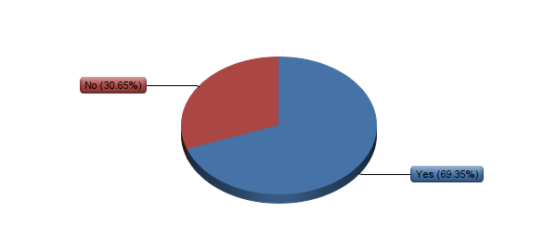

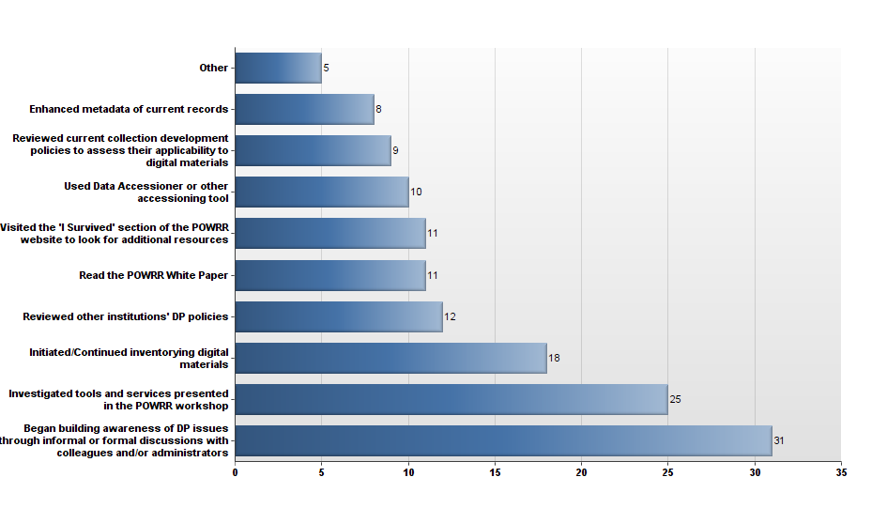

Which activities did you initiate?

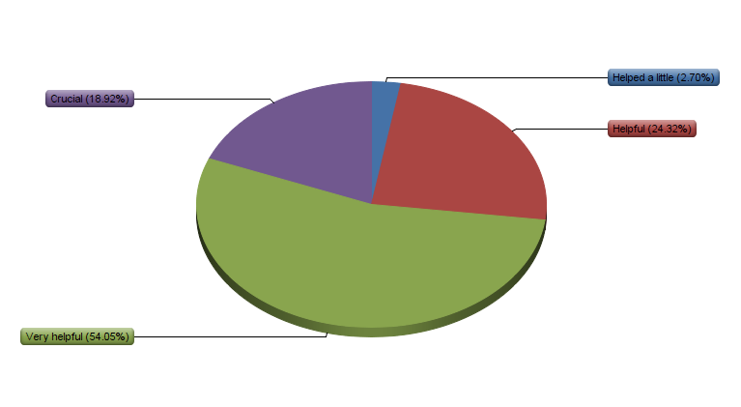

How helpful were the skills and knowledge you gained at the POWRR workshop in choosing and implementing activities?