Why Should Digital Preservation Matter to You?
Intended for: IT
Everyone has a role to play in safeguarding our university’s digital assets.
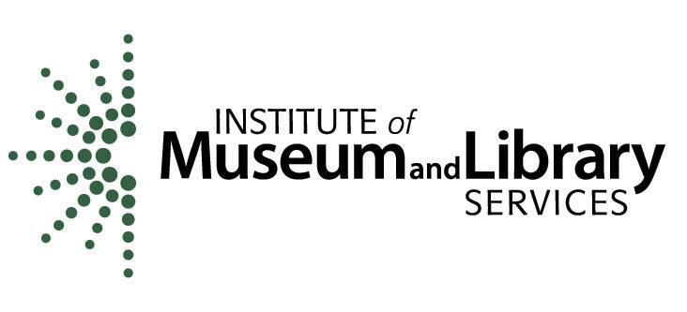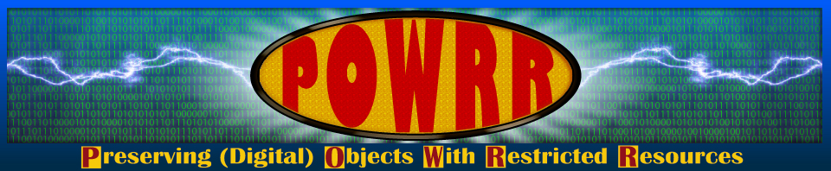
This information is provided as part of the Preserving (Digital) Objects with Restricted Resources (POWRR) project, made possible by a grant funded by the Institute of Museum and Library Services (IMLS). The project is the work of the Northern Illinois University Libraries in conjunction with a board of advisors and partner libraries at Chicago State University, Illinois State University, Illinois Wesleyan University, and Western Illinois University.

The intellectual property of our institution is at risk. While we ensure that our network is secure and we have reliable backup and virus protection, we do not have a digital preservation program to safeguard our intellectual property. This puts all the content we create at risk of being lost.

Current estimates are that without digital preservation electronic records could become inaccessible within a few years, a decade at most. To ensure long-term viability and relevance of our work we need to begin a digital preservation program now.
Facts about Digital Preservation
- Digital preservation is a core service that needs to be managed in concert with other IT programs.

- The IT Department already plays a key role in ensuring content viability campus-wide, tracking and notifying staff of software changes so they can make adjustments. An extension of that role is to monitor hardware obsolescence and ensure files are migrated to new formats—a critical component of a digital preservation program.

- University policies and procedures for managing data need to be expanded to include digital preservation guidelines. Guidelines can help clarify the appropriate selection of files, thereby reducing the amount of storage space needed.

- Digital preservation ensures that files will continue to be accessible over time, not that they are just backed up and stored.

- The university needs to identify multiple locations for storing preserved files. The archive should not be maintained solely on our institution’s servers.

- Digital preservation is programmatic and involves ongoing costs. Plans need to include server maintenance and replacement.

How Can You Help?
Everyone has a role to play in establishing a digital preservation program. Digital preservation activities must become part of our core mission because they secure the intellectual capital represented in our teaching and research products. This is necessary if we are to remain a viable institution and attract and retain faculty, students and staff. We need to get the dialogue started and the funding identified to move this critical program forward.

What is Digital Preservation?
Digital preservation combines policies, strategies and actions to ensure long-term access to content that is born digital or converted to digital form regardless of the challenges of file corruption, media failure and technological change.

Digital preservation is an ongoing process, not a one-time activity, and needs to be addressed programmatically. Digital Preservation is more than a back-up.

Why do we need it?
Digital files become inaccessible over time unless they are managed and migrated to new technology as needed. Even content that resides on a web site or social media site is at risk.

For more information,
please contact:
<<Your Name Here>>
<<Your Contact Info. Here>>

