October 18, 2012

Meg Miner, M.S.
Ames Library
Lynne Thomas
Drew Vandercreek
Northern Illinois University

Dear Meg, Lynne, and Drew:

The Institutional Review Board of Illinois Wesleyan University has approved your exempt application, “Digital POWRR: Preserving digital Objects with Restricted Resources.” This approval is valid for one year, beginning today and expiring October 18, 2013.

The research procedures should be implemented as detailed in your approved IRB application and modifications. You must inform the IRB of any changes in this protocol. Likewise, the IRB must be informed immediately of any concerns that arise concerning the health or welfare of subjects.

Please keep this email as your official notification. Good luck with your research

Sincerely,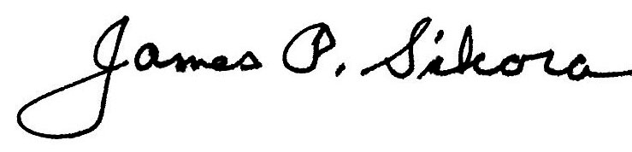
James P. Sikora
Chair, Institutional Review Board,
and Professor of Sociology

